Releases notes v1.10


Releases notes
v1.10
Bugs & Change 3
Improvement 4
Mobile View improv 4
[UI] Improve mobile View #438 4
[COMPANY] Improve mobile view #437 4
[ORDER/QUOTE] improve mobil view #397 4
[TASK] Review view for mobil #394 4
[QUALITY] REVIEW dashboard for mobil view #391 4
[PROFIl] review display form for mobil #393 4
[TASK] Task Dashboard #414 5
[INVOICE] Dashboard invoice #419 5
[PURCHASE] Dashboard #416 5
[OPP] Dashboard and switch card/table line 6
#422 6
[Radquote] Create product from Radquote #384 11
[COMPANY] Add defaut external ID #403 11
[PRODUCT] Add Finishing #402 11
[STOCK] Add Stocks scraps notion #398 11
[User] investigate use laravolt/avatar #388 11
[QUOTE] Create customer information on form #405 11
[PRODUCT] Manage material certificates #404 11
[SUPPLIER] RATE RECEPTION PURCHASE #408 11
[COMPANY] Show purchase list on company page #411 12
[COMPANY] Have the possibility to choose legal entity or company on the customer file #406 12
[PURCHASE] Create purchase ordre, whiout link with task or order #417 12
[COMPANY] ADD barre code to data #439 12

Bugs & Change

#441 - Sur la page de login de la demo, je clique sur le logo et j'ai une 500
#427 - [TASK] Error 500 in production
#395 - [METHODS] Delete ambiguous pagination
#390 - [QUALITY] no NC code display on select
#389 - [Quality] Wrong user select data
#424 - [SEEDER] Improve seeder
#387 - [SEEDER] Improve / add seeder process
#426 - [TASK] Internal delay is not use, in all scipts
#392 - [HR] Translate key missing or wrong
#389 - [Quality] Wrong user select data
#390 - [QUALITY] no NC code display on select
#396 - [TASK] Planning not display task to do if hour is on the past
#395 - [METHODS] Delete ambiguous pagination

Improvement

Mobile View improv

[UI] Improve mobile View #438

[COMPANY] Improve mobile view #437

[ORDER/QUOTE] improve mobil view #397

[TASK] Review view for mobil #394

[QUALITY] REVIEW dashboard for mobil view #391

[PROFIl] review display form for mobil #393
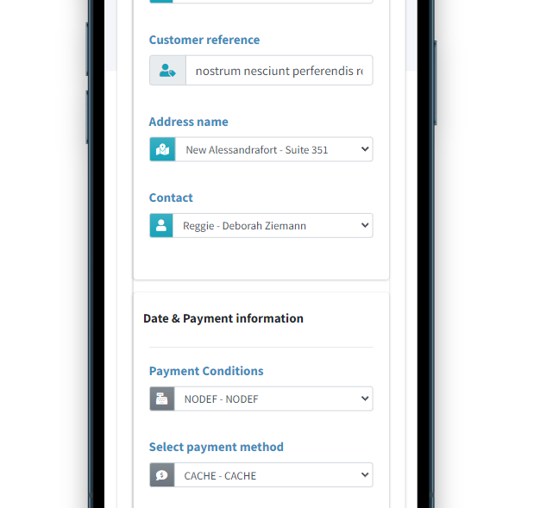

[TASK] Task Dashboard #414

[INVOICE] Dashboard invoice #419

[PURCHASE] Dashboard #416

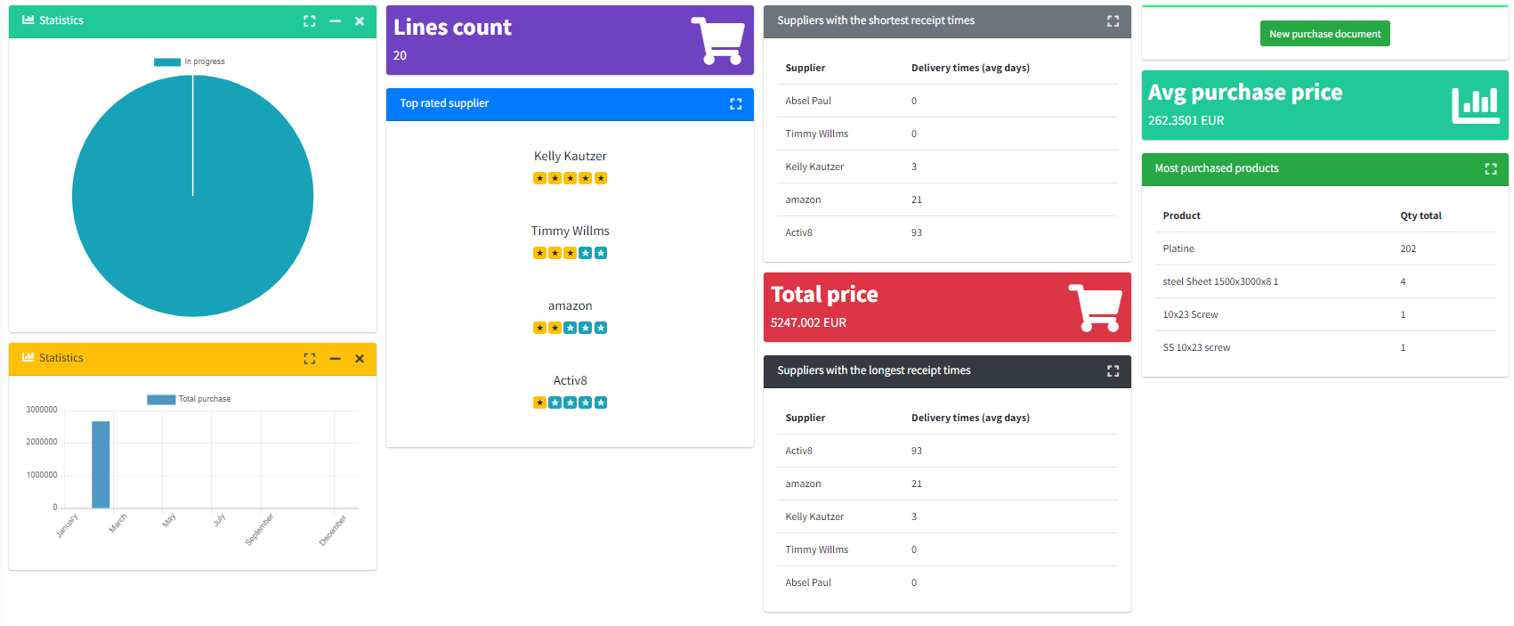

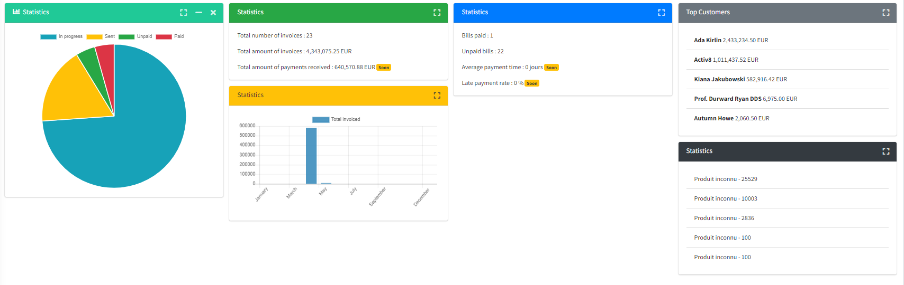

[OPP] Dashboard and switch card/table line

#422

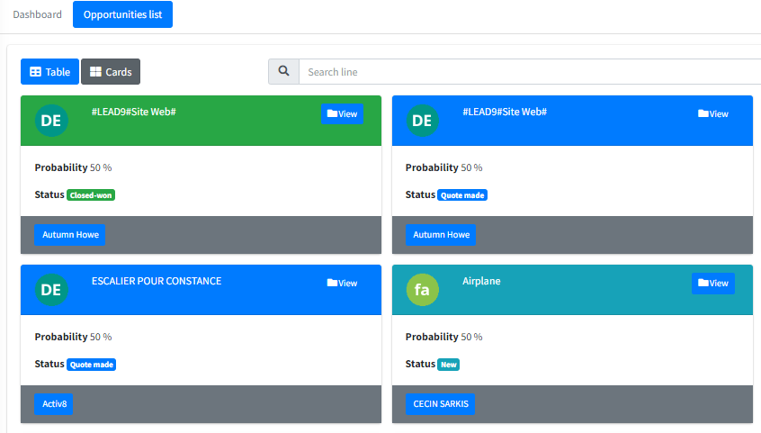
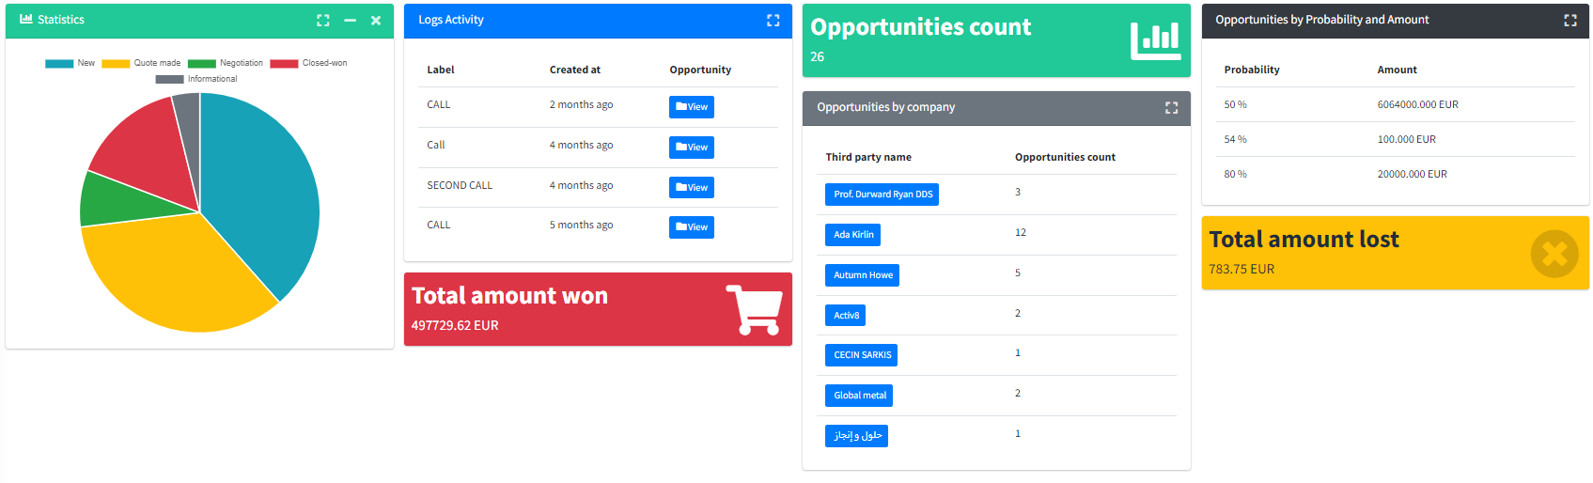

[PURCHASE] TOP rated supplier #415

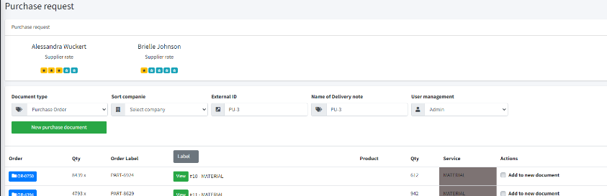

[UI] [FR] Investigate use Select2 #412

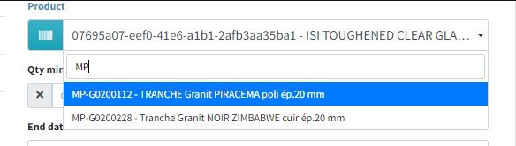

[User] Desactivate acces to user #385

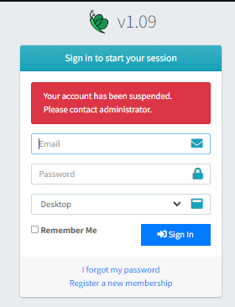

[PRODUCT] Generate bare code on product or Stock #399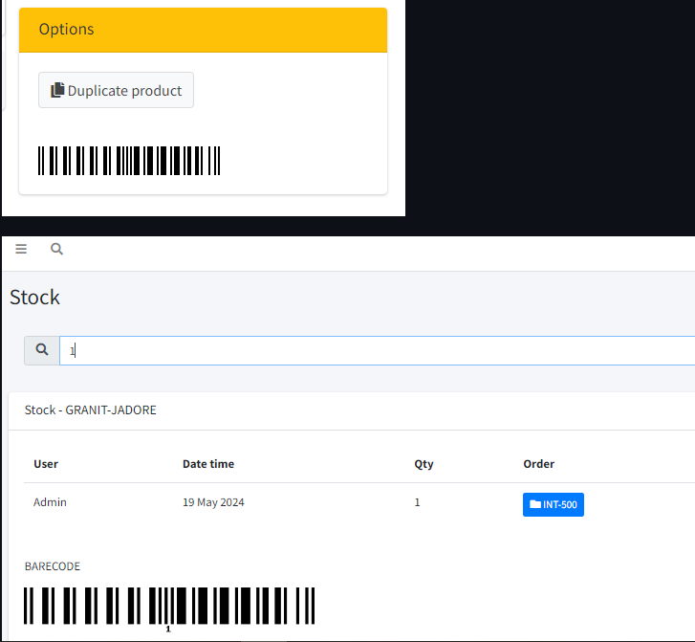

[STOCK] Add picture off stock #400

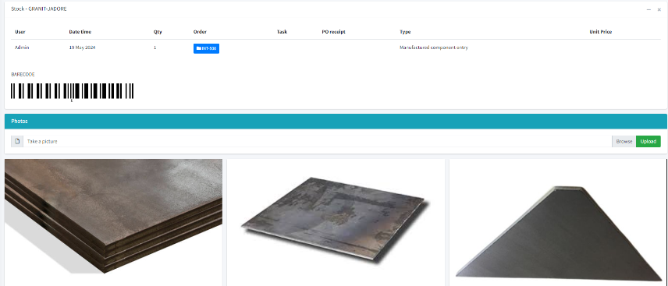

[HR] management of expense reports #289
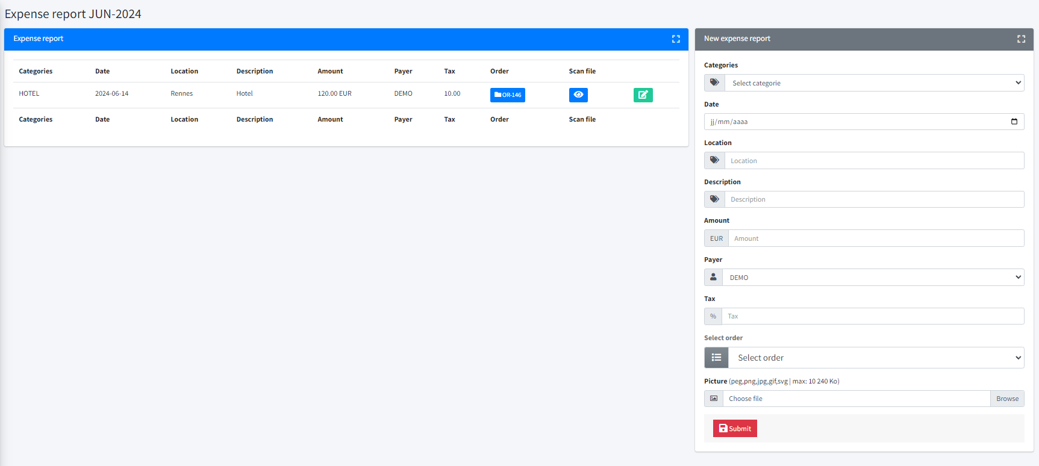

[Radquote] Create product from Radquote #384

[COMPANY] Add defaut external ID #403

[PRODUCT] Add Finishing #402

[STOCK] Add Stocks scraps notion #398

[User] investigate use laravolt/avatar #388

[QUOTE] Create customer information on form #405

[PRODUCT] Manage material certificates #404

[SUPPLIER] RATE RECEPTION PURCHASE #408

[COMPANY] Show purchase list on company page #411

[COMPANY] Have the possibility to choose legal entity or company on the customer file #406

[PURCHASE] Create purchase ordre, whiout link with task or order #417

[COMPANY] ADD barre code to data #439

